Student Halloween Costume Guidelines
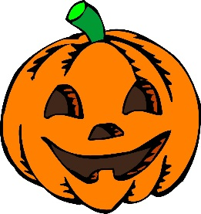
In an effort to make our Halloween celebrations fun and enjoyable for all, we ask that all students who choose to wear a costume follow the guidelines below.
- Due to the current climate around “killer clown costumes” the school has made the decision to ban these at this time.
- Students need to be identifiable and visible to ensure safety. Masks, coverings or make-up that results in staff being unable to identify students may not be worn.
- Appropriate “school” wear is still in order. Costumes that are provocative, revealing, sexual in nature or employ questionable props are not permitted.
- Costumes that depict violence, alcohol or drugs are not appropriate. Fake weapons should not be brought to school.
- Costumes that could be offensive or perpetuate a stereotype of someone’s culture, gender, heritage, or religion are not permitted.
- Costumes should not hinder your ability to travel through the building or stairwells safely.
- Costumes may not be worn during the school day, however, may be worn during the dance and alternate activities offered.
Students wearing costumes that do not meet these guidelines will be asked to change into their regular clothes. If you have any questions or concerns please call Ms. Crapsi.

Talking points for teachers and parents to assist in this teachable moment…
- Remind students of their audience in the building (students, teachers, parents, community members)
- This is a school- what may be appropriate in pop culture or the media may not be appropriate for a place of learning.
- We are a community and we want students to think about how their costume choices may impact others within this community.

