Option Sheet Entry
Step 1: Log into your career cruising account via the Hub
- Go to home.hwdsb.on.ca and click on the Hub link
  - Log in using your school connect account information
- Once in the HUB click on CC (career cruising) in the tool bar
  - you may need to sync your account by entering your career cruising username and password (this only needs to be done once)
Step 2: Click on “Choose My Courses”
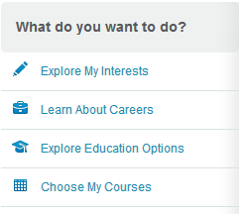
Step 3: Enter your course selections then click the submit button
Step 4: Once you submit, your selections are locked. You will be prompted to print off a Course Request Sign Off Sheet. Print this form and return it signed by a parent or guardian to your homeroom teacher.
