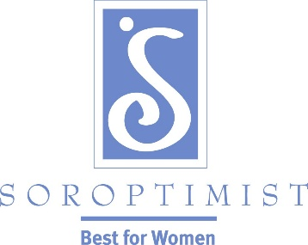
Soroptimist International of
Hamilton –Burlington

ANNOUNCES THE ‘LIVE YOUR DREAM’ AWARD

FOR 2017/2018!

AN EDUCATIONAL OPPORTUNITY FOR WOMEN

PLEASE HELP PUBLICIZE THIS AWARD BY PUBLICIZING THE INFORMATIONAL POSTER, WHICH IS ATTACHED.

Note: Deadline is November 15, 2015

Amounts of Award: $1,000 and $500

Please return Application and Reference form to:

Danielle McKirgan, Awards Chair
45 Rose Cres.
Stoney Creek, ON
L8G 3W6

THANK YOU FOR YOUR ASSISTANCE

