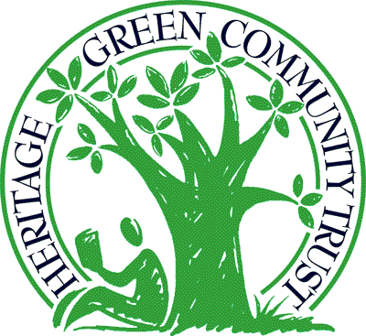

Don’t miss out on this great opportunity!
Application packages, including program details, are available through the Heritage Green Community Trust website:

www.heritage-green.org

For further information contact:

Kim Bailey, Trust Administrator
Tel: (905) 548-5877
E-mail: HGCT@terrapureenv.com

The Heritage Green Community Trust believes in giving back to the community of Upper Stoney Creek. What better way to give back than to promote continuous learning and higher education to the students living in our area?
The Heritage Green Community Trust Scholarship Program provides financial support to students to continue their education at the post-secondary level who put forward visionary ideas to stimulate community building.

Heritage Green Community Trust Scholarship Program

Application Deadline: April 1, 2016

Application packages may be submitted to: Heritage Green Community Trust
c/o Terrapure Stoney Creek Landfill
Ref: HGCT Scholarship Program
65 Green Mountain Road W.
Stoney Creek, ON
L8J 1X5

Share your ideas to build a better community.
Up to Ten $2,500 scholarships will be awarded in 2016!

