

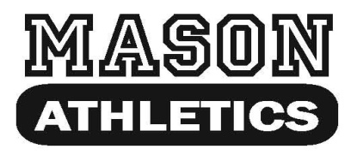LINCOLN ALEXANDER

16 McMurray St. Dundas SPIRIT WEAR ORDER – 2017

www.masonathletics.com

905-627-1922

Sizing samples will be available: Thursday November 2nd & Friday November 3rd

Please submit orders with payment to the office by: Wednesday November 8th .

Please remember to circle the size and color you are ordering and fill in the quantity.

|  |  |  |  |  |  |
| --- | --- | --- | --- | --- | --- |
| **Item Description** | **Size** | **Color** | **Price** | **Quantity** | **Subtotal** |

|  |  |  |  |  |  |
| --- | --- | --- | --- | --- | --- |
| **1) T-SHIRT**  Ultracotton Tee  *Includes 2 Colour Crest* | **Youth:**  Small, Medium, Large, XL  **Adult:** Small, Medium, Large, XL , XXL | Navy  White | **$15.00** |  |  |

|  |  |  |  |  |  |
| --- | --- | --- | --- | --- | --- |
| **2) HOODIE**  50/50 Blend  Hooded Sweatshirt  *Includes 2 Colour Crest* | **Youth:** Small, Medium, Large, XL  **Adult:** Small, Medium, Large, XL , XXL | Navy  Grey | **$30.00** |  |  |

|  |  |  |  |  |  |
| --- | --- | --- | --- | --- | --- |
| **3) BALLCAP**  100% Cotton Twill  6 Panel Structured  *Includes 2 Colour Embroidery* | **Youth**  **Adult** | Navy | **$15.00** |  |  |

|  |  |  |  |  |  |
| --- | --- | --- | --- | --- | --- |
| **4) TOQUE**  100% Acrylic Knit  *Includes 2 Colour Embroidery* | **Beanie**  **Rollover** | Navy | **$15.00** |  |  |

|  |  |
| --- | --- |
| ***PRICES INCLUDE TAX*** | |
| ** make **cheques** payable to Lincoln Alexander School ** **TOTAL** | _________ |

**NAME: __________________________________________________ GRADE: ___________________________**

**PHONE #:________________________________TEACHER:__________________________________________**

**Delivery is expected by December 20, 2017.**