STAYING UP TO DATE FROM HUNTINGTON PARK’S SCHOOL WEBSITE
IS JUST A CLICK AWAY…

Calendar of Events School Council News Twitter

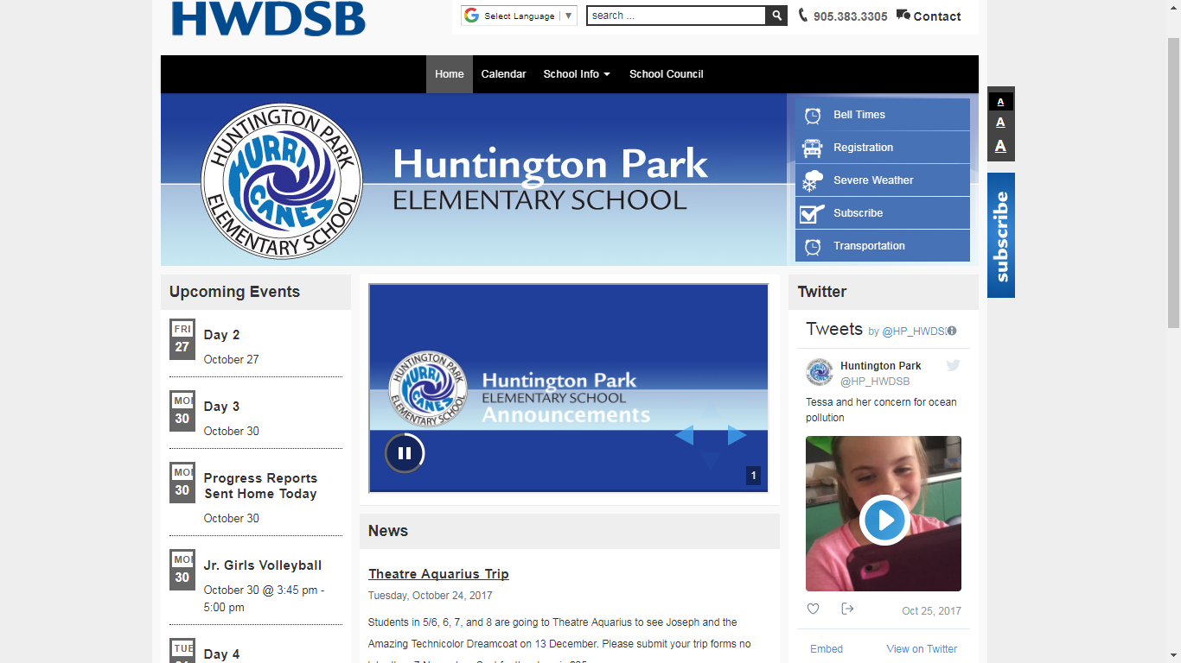
Morning Announcements:  The announcements  said each morning to our  students and staff can be found  here. | Subscribe:  If you subscribe to the website, you will receive email notifications when the website is updated.

News:
Where current news will be posted. For example, if the bus is late in picking up the students, after 3:30 p.m., it will be posted here.

