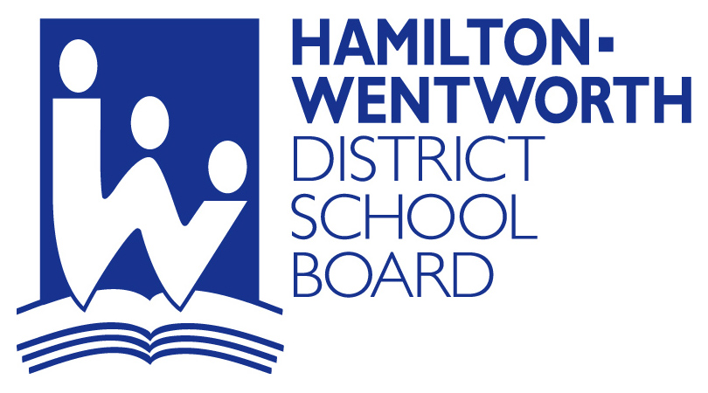
GLENWOOD SCHOOL
150 LOWER HORNING ROAD
HAMILTON, ONTARIO L8S 4P2
Tel: 905-525-2140
Fax: 905-525-2312
Keith Muldoon - Principal

Glenwood Special Day School!
January 14, 2013

PRINCIPAL’S MESSAGE
I would like to begin the New Year (2013) as I do each year, by thanking our families and school staff for teaming together to make good things happen for the wonderful students of Glenwood School. Thank-you to all of our families for the many thoughtful words, greetings and gifts received over the last week of school. They were certainly appreciated (though not necessary). We wish for each of you and your family members good health, happiness and all the best throughout the year, 2013, and beyond.
As I look to our parents, I would like to thank you for your guidance and responsiveness to the messages we send home and the special events that are held for students. And as I turn to the staff, I must thank them for their creativity and the energy they put into making “fun things” happen at Glenwood. Let me assure you that our students have some wonderful activities and experiences at school. From special assemblies, dances, movies to special activities both in class and around the building there is so much happening. The front hall is lined with pictures of students engaged in all kinds of exciting things and the smiles on their faces tell the story…They’re having fun!
Many of the special shows and presentations that have been enjoyed are thanks to School Council for providing the money to invite quality performers and presentations into the school. As you may recall, our swimming program has not been running this year and this has allowed Council to direct funds that would have otherwise been used for transportation to be used on activities that are reaching a greater number of students.

Christmas Blizzard (formerly called our Shopping Spree)
This event was held again this year and we trust that family members were pleasantly surprised by gifts acquired for them at this special Glenwood event. (Your contributions were also greatly appreciated.)
What you may not have known is that one of the creative and practical additions to this event this year was service right to the classroom with a mobile cart of items and the implementation of I Pad shopping that allowed students who were not able to get to the gym to scan (real) pictures of items they could choose as gifts and select them by touching the screen. Those items could then be gathered and brought to the classroom. We thank the staff for all the work that went into preparing for, setting up, and delivering this special opportunity.
The following statement has been shared at times before, but I share it again with a couple of notations. I believe that it describes our Glenwood families and the staff at Glenwood who work with our students each day.

It takes a special person, with patience and wisdom to share, to unlock the treasure awaiting within children everywhere! You are certainly those special people working (with us) to unlock the treasures within your children.

Remember: COMMUNICATION with the OFFICE
We are fortunate to have a knowledgeable and energetic Administrative Assistant, Barb Pottier, working in Glenwood’s front office meeting visitors, answering the telephone and doing a myriad of tasks and duties to make sure the school is running smoothly. Please be sure that you have the school phone number readily available. If we need to be aware of a situation regarding your child, call us. If your child is absent or will be coming from or going to “Alternative Care” let us know. Calls regarding absences can be made between 8:00 and 8:45 a.m. to speak to Barb, or earlier if you just wish to leave a message.

Glenwood’s Phone Number is: 905-525-2140

Your Phone Number is: ???-???-????

PLEASE BE SURE THAT WE HAVE ALL NUMBERS AT WHICH YOU MIGHT BE CALLED IN TIME OF EMERGENCY OR NEED.

If you need to speak to the teacher:
Please note that when you call, your child’s teacher may not be able to come to the phone immediately to speak with you. The class is his or her first responsibility and getting to a phone may not be possible. However, we welcome your call. Teachers will make an effort to get back to you as soon as possible.

CLASS NEWS!
Some classrooms may share by way of a class newsletter or may be planning to pass something along in our next newsletter.

OTHER IMPORTANT MESSAGES!
PLEASE BE PATIENT WITH US AS WE SHARE SENSITIVE MESSAGES AND UNDERSTAND THAT WE ARE NOT SHARING THEM TO UPSET OR ANGER YOU. WE ARE NOT INTENDING TO TELL YOU THAT YOUR CHILD IS “BAD”. It is JUST a message that we feel needs to be shared.
Here are a few examples:

Lunches – The Board has a nutrition policy that encourages everyone to have healthy and nutritious snacks and lunches. Clearly a healthy, well balanced lunch diet will include foods that are appropriate. If a child is regularly bringing a lunch filled with sugary or packaged treats they may missing out on adequate sized portions of healthy types of foods (fruits, vegetables, sandwiches, soups, etc.) Please make an effort to ensure that your child is bringing appropriate snacks and lunches.

Illness – VULNERABLE / FRAGILE STUDENTS ARE AT RISKS OF SERIOUS, LIFE THREATENING ILLNESS OR TRIPS TO THE HOSPITAL AS A RESULT OF SICK CHILDREN ARRIVING AT SCHOOL. If your child comes to school with a fever, cough or sneezes that could be enough to cause illness to spread to other students and staff. We really do want our students healthy and well, and we want the same for the people who work with them daily (the staff). Help everyone by keeping your child home if they have symptoms of illness. *We may need to call and request a pick-up if your child shows symptoms of illness.

Behaviour – As many of you know, on almost a daily basis, staff members at Glenwood report injuries related to the aggressions of students. Even as I write this message, we have one staff member completing a period of recovery after having a severely broken thumb that required treatmemt and a visit to a plastic surgeon. The injury occurred about two months ago. An injury that could cause permanent damage could put a staff member out of work permanently. Our calls for help are not meant to annoy you or to criticize you or your child. They are simply a call to inform and to ask for your help. That help may mean – PLEASE COME AND GET THEM. There is a limit to what we are able to manage and your help is needed.
Phone numbers (and addresses) – PLEASE MAKE SURE THAT WE HAVE ALL OF YOUR PHONE NUMBERS, PARTICULARLY WHEN THEY GET CHANGED. MAKE SURE THERE IS SOMEONE WE CAN DEFINITELY CONTACT IN THE CASE OF AN EMERGENCY. Believe it or not, we have had to send students to the hospital and their parents did not know, because we were not able to contact the family or emergency contact. (Giving us your home number as the “emergency contact” is NOT SATISFACTORY. – If you don’t answer it the first time, calling it as an emergency number won’t work either. Please be sure that there is someone we can contact.)

Requests for ? - Sometimes we “run out” of something that is needed in the care of your child. Extra clothing, additional diapers or wipes, a larger lunch, a different or extra snack may be requested. Your patience and prompt assistance is appreciated.

THIS IS ONLY A PARTIAL LIST OF POSSIBLE MESSAGES YOU MAY RECEIVE. SUCH MESSAGES ARE NOT INTENDED TO ANNOY, INCONVENIENCE, ACCUSE OR EMBARRASS YOU! They are simply presented as another way in which we may support one another in the task of doing what is best for our students.
We thank-you for your understanding and help! If you have any questions please contact us at the school.

ALLERGIES ARE REAL!
As you know, there are many kinds of allergies and conditions that affect the health of individuals. Among the common and recognized allergies are: nuts (peanuts), lactose (milk), latex (rubber). Did you know that we have two individuals at Glenwood with other allergies that affect their health, and require epi-pen treatment? In some cases, individuals have been known to have allergies to perfumes, odours, mould. One of our teachers has had to be treated in hospital because an anaphylactic reaction to “carrots”. While we can’t possibly anticipate all potential allergies and respond to them, all families are asked to remember:
GLENWOOD SHOULD BE CONSIDERED A “NUT FREE” FACILITY Food that has or could contain “nuts” or “nut products” should not be included in snacks and lunches that students bring to school.

BUS BITS! – Don’t forget to call!
Please remember that buses cannot wait long for students in the morning or for someone to take them off the bus at the end of the day. SOMEONE should accompany students to/onto the bus in the morning and meet them to take them of at the end. Please help the driver and other families by being on time.
IF YOUR CHILD IS GOING TO BE ABSENT CONTACT THE BUS COMPANY TO LET THEM KNOW!

ATTRIDGE – 905-690-2632
CALEDONIA – 905-692-4488

COUNCIL UPDATES – Help to support the efforts of YOUR School Counci!

GIFT CARD (FUNDSCRIP) PURCHASE – THROUGH GLENWOOD
Currently, School Council is continuing this as a monthly and ongoing fund raising opportunity. It is an unbelievably simple way of generating funds for the school because gift cards can be purchased and spent with no loss of value, but the school receives a percentage of their value. Some Council Members and others have opted to purchase gift cards for places they already shop… a particular grocery store etc. You don’t have to give the card away, but can keep it to make your own usual purchases. Doing it this way allows the school to receive a percentage of the value of the card being used. If you need more information contact the school and we will arrange for a Council Member to be in touch.

UP AND COMING - Glenwood’s Annual Golf Tournament – At this moment in time plans for this event have not been confirmed. Council will be reviewing and determining the viability of holding the event this year. They are also exploring a few other ideas. Remember: Regardless of what event is planned, you are encouraged to support it to whatever extent and in whatever ways you are able. A successful event will bring in funds to support and provide special activities for some great people – Our Students!
Stay tuned for further announcements!

Watch for more information coming to you in the days ahead!
JANUARY
January 25 | Professional Activity
February
Feb. 12 | Mary Moore – Westdale Library – 1:30 p.m.
Feb. 13 | School Council – 7:00 p.m.
Feb. 14 | Valentines Assembly – Dance
Feb. 15 | PD Day
Feb. 18 | Family Day (holiday)
Feb. 21 | Tentative – FAMILY FUN NIGHT – 6-8 P.M.
March
Mar. 6 | School Council – 7:00 p.m.
Mar. 11 – 15 | March Break
Mar. 29 | Good Friday – holiday
APRIL
April 1 | Easter Monday – holiday
Apr. 9 | Mary Moore – Westdale Library – 1:30 p.m.
Apr. 10 | School Council – 7:00 p.m.
MAY
May 7 | Mary Moore – Westdale Library – 1:30 p.m.
May 8 | School Council – 7:00 p.m.
May 14 | Sackville Hill Seniors Choir
May 20 | Victoria Day holiday
JUNE
June 3 | PD Day
June 11 | Mary Moore – Westdale Library – 1:30 p.m.
June 12 | School Council – 7:00 p.m.
June | Glenwood’s Annual Golf Tournament ? decision pending
June 26 | Graduation
June 27 | Awards Assembly – Last Day for students
June 29 | Professional Activity Day

Thank-you! K. Muldoon, Principal

A child’s life is like a piece of paper on which every person leaves a mark. Chinese Proverb
Thought: What kind of a mark we leave is up to each of us….

