Delta Secondary School
Parenting
Grade 11, Open
HPC 3O
Family Studies Department

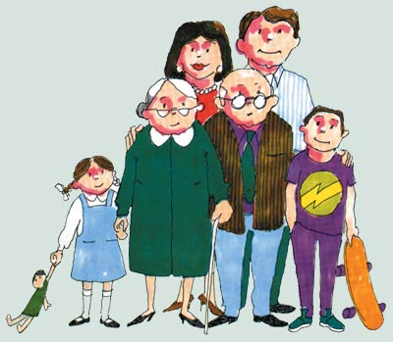
Course Description

This course focuses on the skills and knowledge needed to promote the positive and healthy nurturing of children, with particular emphasis on the critical importance of the early years (0–6 years) to human development. Students will learn how to meet the developmental needs of young children, communicate, and effectively guide early behaviour. They will have practical experiences with children 0 – 6 years of age and will learn skills in investigating questions relating to parenting.
Units of Study:
Unit | Title
1 | Parenthood: Responsibilities and Realities  - Explore positive and negative reasons to become a parent  - Identify key parenting characteristics and responsibilities  - Analyse effective ways to prepare for parenthood  - Identify various types of families and unique values and traditions in Canada and other cultures  - Identify challenges families with young children often face such as child abuse, illness, divorce etc.
2 | Conception, Pregnancy and Prenatal Care  - Explore the conception, pregnancy and birth process  - Identify key aspects to having a healthy pregnancy such as nutrition and exercise  - Discuss the impact of drug and alcohol use on child development  - Compare pregnancy and delivery in different cultures  - Explore and research issues such as infertility and birth defects and the impact they have on families
3 | Adjusting to Parenthood  - Identify the characteristics of infants  - Explore the family adjustments to having a newborn and issues such as post-partum depression  - Identify proper ways to care for an infant and promote healthy development  - Participate in a RealCare© baby simulation and evaluate your own parenting skills
4 | Nurturing and Guiding Children  - Analyse different parenting techniques and the effect each has on the child  - Examine why play is important for children  - Explore effective and ineffective ways to communicate with children and deal with misbehaviour  - Identify the differences in raising children in various cultures.

Delta Secondary School
Family Studies Department

Evaluation

Knowledge and Understanding | 25%
Thinking and Inquiry | 25%
Communication | 25%
Application | 25%
- 70% of the final grade will be based on course work
- 30% will be based on a summative evaluation in the form of an examination and/or performance assessment given towards the end of the course

Learning Skills
Responsibility | Organization | Independent Work | Collaboration | Initiative | Self-Regulation
Lateness to class, use of time in completing assignments, homework, participation in class, absences, working with others, etc. will be reflected in the learning skills section of the report card.

Due to the practical nature of this course, you must attend everyday. You may not always be given an opportunity to complete missed work. This will be up to the discretion of the teacher.

You are expected to be on time and equipped with a notebook and pen. It is suggested that you use a daily planner to record important due dates. There is a posted calendar in the classroom to help you keep organized and informed.

Some course content is sensitive in nature. You must show respect to everyone in the class and be open to the opinions of others. You are expected to behave maturely.

Completion of the RealCare© infant simulation project is an expectation in this course. Please discuss any concerns you have with the teacher within the first two weeks of class.

