DELTA SECONDARY SCHOOL

Course: HIF1O, Grade 9
Prerequisites: None
Guideline: The Ontario Curriculum, Grade 9, 1999
Text: Individual and Family Living in Canada

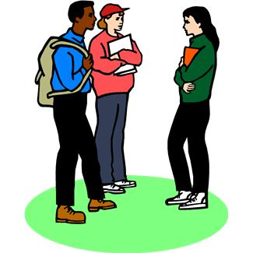
Course Description
This course explores the challenges faced by all people: how to meet basic needs, how to relate to others, how to manage resources, and how to become responsible members of society. Students will acquire the knowledge and skills that are needed to make the transition to adulthood. Teachers will instruct students in developing interpersonal, decision-making and practical skills related to daily life. Students will explore the functioning of families and the diversities found among families and within society.

This course is divided into 4 units with the following Big Ideas as the main foci:

Unit 1: Nutrition, Food Preparation and Healthy Living
- apply practical cooking and food preparation skills for daily-living tasks
- demonstrate practical skills such as meal planning and nutritious food choices that contribute to the functioning of families
- demonstrate effective collaborative group skills in food lab teams
Unit 2: Adolescent Issues and Decisions
- describe the characteristics of development in adolescence, and explain how different factors can influence self-esteem and teenage behaviours.
- analyse strategies to develop and maintain effective relationships with friends and parents
- apply parenting skills by participating in the Baby Think It Over program
- understand and apply problem-solving and decision-making skills, to issues such as abuse, bullying and teen pregnancy
Unit 3: Managing Resources: Employment, Housing, Budgeting
- describe strategies by which individuals and family members create and manage a budget and household chores such as laundry, cleaning and simple sewing
- demonstrate an understanding of smart shopping and why being an informed consumer is important
- use social science research methods to research careers and apply for jobs
Unit 4: Family Life
- summarize the functions of families in society and learn what happens when families break down
- learn why solving problems with family members and friends is important and discuss effective vs. ineffective strategies

Daily Expectations

- Due to the practical nature of this course, you must attend everyday. You may not always be given an opportunity to complete missed work. This will be up to the discretion of the teacher.

- You are expected to be on time and equipped with a notebook and pen. It is suggested that you use a daily planner to record important due dates. There is a posted calendar in the classroom to help you keep organized and informed.

- Some course content is sensitive in nature. You must show respect to everyone in the class and be open to the opinions of others. You are expected to behave maturely.

Assessment
Your assessment will be based on the overall course expectations but will be broken down as follows:

Knowledge and Understanding | 25%
Thinking and Inquiry | 25%
Application | 25%
Communication | 25%
- 70% of the final grade will be based on course work
- 30% will be based on a summative evaluation in the form of an examination and/or performance assessment given towards the end of the course

