Cathy Wever Celebrates French with Gregg LeRock!

Tuesday March 5th was a great day for a celebration of French Language and Culture with our grade 4, 5 and 6 students at the Gregg LeRock Concert at The McIntyre Performing Arts Centre (at Mohawk College).

Our Junior French Program worked together with teachers and students to raise money to give every junior student the opportunity to attend the concert. The Junior French Team organized our Holiday and Valentine's Dance Fundraiser and Candy Grams.

We also applied for a $1000 grant through the Government of Canada's Canadian Heritage Department. The grant was being offered schools participating in programs and excursions that promote bilingualism and learning about French language and culture. And, we got it!!!!

After all of our hard work the cost of the trip went from $17.00 down to $6.50! Great job Cathy Wever! Over 150 students, teachers and volunteers from Cathy Wever attended the concert.

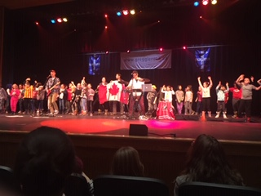
Our students had an amazing time at the concert. What a great fun way to experience French language and culture outside the classroom in a real life situation. C'est Fantastique!

Merci Beaucoup!

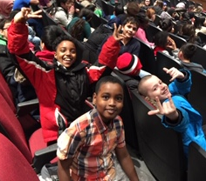
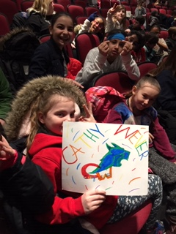

Trentyn"I like how me an Amrala went on the stage to dance"

Mackenzie Taylor "I like that the concert was in French and that I could understand most of the words and most of the songs i loved"

Amethyst" I like that he sang Terry Fox song I know"

"I love the songs Terry Fox an Au Canada an I loved how he let kids on the stage to dance super fun" grade 5

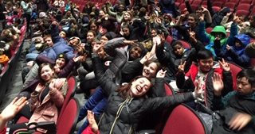
"J'aime le Gregg calling people up to the stage and the music that he played. i loved how he let people played his guitar also that he let Mme. Nazi to go on the stage 😊it wa amizing i love it!"Grade 5

