460 Wentworth Street North
Hamilton, Ontario
905-526-1558

AFTER SCHOOL PROGRAMS
DROP IN PROGRAMS
Monday to Friday
3:00-6:00pm
5-17 years
No Charge, Free

Activities: Games room, Creative Crafts, After school Snack,
Be Active in the Gym, Music, Computers, Literacy Express Train, Breakfast program, and much more...
Registration: Sign up for free

P.A. CAMP - Begin the Adventure and Learning…

Various days in October 2018 to June 2019
Public and Catholic School Boards
Grades 1 to 8 or ages 5 to 12

9:00-4:00pm / $5.00/per child/per PA DAY

Early and Late drop off/pick up Available for an
additional $5.00/child/week - (8:00-5:30pm)
Register today, Limited Spaces
Visit our website for Registration Forms – www.evarothwell.ca or pick up the forms at the Centre

Bug Busters

The City of Hamilton, Public Health Department will be running clinics to screen and offer parents to help and assistance in treating head lice.
Clinics are every Tuesdays from 3:30-5:30 at the Eva Rothwell Centre.

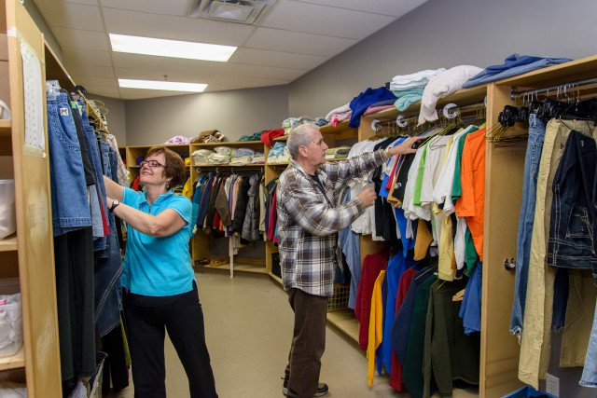
Clothing Room

The clothing room program provides cost-free help for families and individuals in need. Currently, there are over 600 visits per month.

Tuesdays and Thursdays from 10:00am to 12Noon and 3:00pm to 5:00pm

To donate to the Clothing Room Program, please drop off clean and gently used clothing. No household items, furniture or stuffed animals please.

Emergency Food Pantry

The Emergency Food Pantry is available to anyone in need and currently supports over 600 families a year.
Service available from 10:00am to 4:00pm, Monday to Friday.

Please contact us to donate. Though all donations are accepted and greatly needed, we are always in need of:
- Canned Fruit, Rice, Pasta, Kraft dinner, canned vegetables and Peanut Butter

