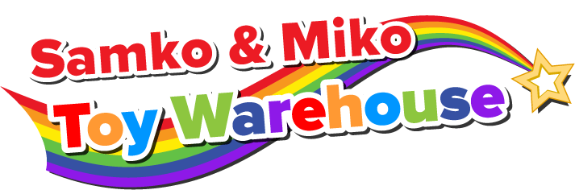
Fundraiser

1
3
Shop at either the Hamilton, or Toronto and Richmond Hill locations of Samko & Miko Toy Warehouse (Hamilton from December 3 – 6 and Toronto/Richmond Hill from
December 9 – 24) and Samko & Miko will donate 10% of your purchase to Bellmoore!
Feel free to share with your friends and family.

It’s as easy as 1, 2, 3!

2
SHOP
STAMP
SUBMIT
WHEN:
Hamilton – December 3rd to
December 6th
Toronto and Richmond Hill -
December 9th to December 24th

WHERE:
3 LOCATIONS:

HAMILTON
Canadian Warplane Heritage Museum - 9280 Airport Road
-or-
TORONTO - 77 Fima Cres
-or-
RICHMOND HILL - 60 East Beaver Creek Rd

Inform the cashier that you are part of a fundraiser by providing the cashier with our group name:

Bellmoore Elementary School

They will then stamp the back of your original itemized receipt.
Submit your ORIGINAL itemized stamped receipt to the school by
Friday January 15, 2016

**Keep a photocopy or scan of your receipt. Samko & Miko will accept a photocopy or scan of your receipt in the event that an item is defective and needs to be replaced**

See the Samko & Miko Toy Warehouse flyers for maps, hours of operation and some of their specials

