BALACLAVA SCHOOL
MEET THE TEACHER EVENING
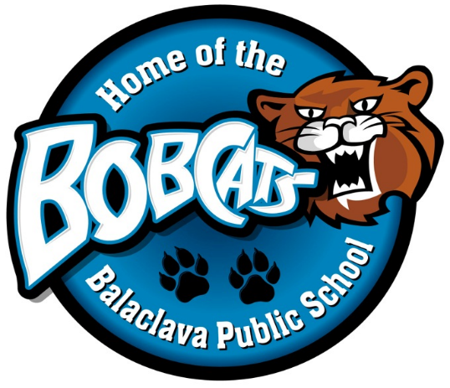
THURSDAY, SEPTEMBER 14, 2017
5:00pm-6:30pm

- Mix & Mingle with Balaclava Staff on the school playground

- Join us a Harvey’s BBQ at the Balaclava Pavilion (no pre-orders needed):

Burgers $5.00 Hamburger Combo $6.50

Hotdogs $4.50 Hot Dog Combo $6.00

Veggie burgers $5.00 Veggie Burger Combo $6.50

Pop/Chips $1.25 (Combos include pop & chips)

*Please ensure that all children are accompanied by an adult throughout the evening. Thank-you in advance for your cooperation in this matter.

** Parking will be available on the intermediate playground **
In the event of rain, our Meet the Teacher will take place in the gym. The BBQ will continue rain or shine.

