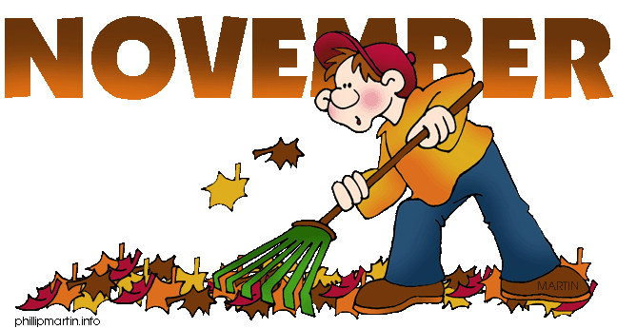 | 2017

Sun. | Mon. | Tue. | Wed. | Thu. | Fri. | Sat.
 |  |  | 1 TCBY | 2 | 3 | 4
 |  |  | Rock the Orchestra Trip  Grades 4 and 5 | Pizza Day | P.A. Day  Parent/Teacher Interviews
5 | 6 Popcorn | 7 | 8 TCBY | 9 | 10 | 11
 | PICTURE RETAKES |  | Fred Penner Trip  Grades 1 to 3
12 | 13 Popcorn | 14 | 15 TCBY | 16 | 17 | 18
 | School Bus Safety – Pr. @ 9:00 a.m.  Jr. @ 11:00 a.m. |  | Hamilton Bulldogs Trip  Grades 4 and 5
19 | 20 Popcorn | 21 Popcorn | 22 TCBY | 23 | 24 | 25
 | Lunch Lady  Chili Days,  School Council  6:30-8:00 | Electricity Safety Assembly  Jr. @ 8:30 a.m.  Pr. @ 10:45
26 | 27 | 28 | 29 TCBY | 30

notes | December 1 - P. A. Day No Scheduled classes  December 18 - Lunch Lady – Holiday Dinner  December 25 to January 5 -- Winter Break

