Dear Westview families

The Parent Council is inviting you to join our fundraising program.

The funds raised throughout the school year are used for many projects and activities as field trips and presentations that improve and enhance our students’ experience. Engaging students in science, arts and technology is one of the most important factors in creating tomorrow’s world.

There are two different platforms that our school has joined in.:

Fundscrip Fundraising Program offers options to purchase gift cards either by filling the physical order form attached to this letter as well as an online subscription. This fundraising option is an innovative program that lets our school earn cash rebates for things you buy everyday like groceries, gas and other household items.

Flipgive Fundraising Program is a cash back site for groups that combines the convenience of online shopping with the best of online fundraising, making it easier for groups to raise money. Groups using FlipGive earn up to 25% cash back for our school simply by shopping with retail partners. It’s a fast, easy and free way to support our school. We even earn an extra $5 when you make your first purchase.

How does Fundscrip work?

GIFT CARDS are purchased at face value from FundScrip. Use the form provided from participating retailers, and a percentage of every purchase (listed on the form in the % column) is contributed to our school’s fundraising efforts.

Instead of paying with cash or a debit card, you use a gift card that you purchased through our group.
You will receive the full value of the cards. It costs you nothing extra but you just earned money for our school.
We encourage everyone to invite their family members, friends, co-workers and neighbors to participate in our FundScrip gift card fundraiser as well.
A complete list of the participating retailers and the November specials can be found on the order form.
The deadline to return your order forms to the school is:

Friday, November 10th, 2017 and orders will be sent home after November 27, 2017
Cheques are payable to: Westview School

In addition to the paper ordering Fundscrip also offers on-line ordering.

Here is the link of the website: https://www.fundscrip.com/.
Click the button on the upper right corner. On the next page, enter the Group Invitation Code “JZJUW7” (note: the case matters) and fill in your information, then check “I agree the term and conditions”, and press .

Once you confirm your registration through email, you can start shopping.

How does FLIPGIVE work ?

Flipgive is an online shopping platform that rewards the group you support with a percentage of your purchase at no expense to you! The percentage earned varies by retailer with some offering up to 25%! There is a wide list of participating retail stores, Sports, Fashion and many other items. Join
our school team by visiting:
www.flipgive.com/teams/110545-westview-middle-school/joins/intro?fundraiser_name=Westview+Parent+School+Council

Or for more information here's a list of the brands and restaurants you can shop: https://www.flipgive.com/f/466066

Both links will be posted on our school website.

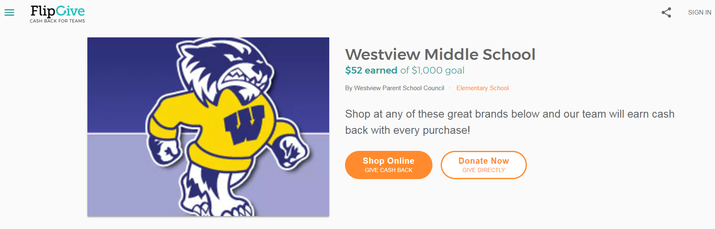

With the holidays fast approaching consider both of these options as well to simplify your shopping!

Raising the funds will be an ongoing activity through the whole school year.

Thank you for helping us to improve our student’s experience!

Sincerely,
Parent Council

