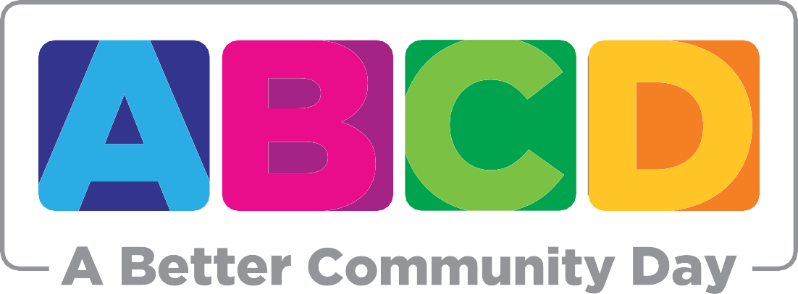

What is ABC Day?
A Better Community Day, also known as “ABC Day”, is an event that pairs volunteers with local
not-for-profit organizations to facilitate a day’s worth of positive action in the community. The vision behind ABC Day is to make tomorrow’s Hamilton better than today’s through volunteer activities across the city.

ABC Day started as a grassroots volunteer initiative led by the 2015/16 MSA Board of Directors, and has since grown into an annual Hamilton community event. The inaugural ABC Day took place on April 3, 2016 with over 100 participating students and community members. Volunteers signed up to support one of three organizations: the Escarpment Project, Eva Rothwell Centre and Food4Kids.

For ABC Day 2016/17, participation doubled to over 200 registered volunteers. With this increase in student and community volunteers, three new non-profit partners were added: Mohawk College’s Fennell Orchard, Habitat for Humanity, and the Kiwanis Boys and Girls Club. The day’s activities resulted in more than 800 total hours of volunteering.

To date, ABC Day has received media coverage in local news outlets, including the Hamilton Spectator and Hamilton Mountain News. The 2017/18 ABC Day is scheduled to take place on Sunday, April 8 and will once again build on the success of previous years.

What is the Mohawk Students’ Association?
The Mohawk Students’ Association is the elected student body at Mohawk College. The Association represents more than 30,000 full-time, part-time, continuing education, apprenticeship students.
The MSA’s mission is to enhance all students’ college experience through leadership, support and advocacy.

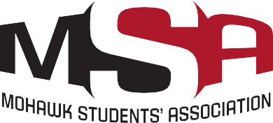
For more information about ABC Day, please contact:
Samantha Hoover
President, Mohawk Students Association samantha.hoover@mohawkcollege.ca 905-575-1212 ext. 3217

