Cleaning Closets, Supporting Kids

Dr. Davey School, Hamilton
is in need of gently worn
childrens’ shoes
Sizes 10,11,12,13,1,2,3,4,5
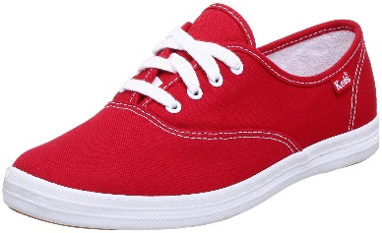
And coats, jackets and hoodies of all sizes

Collecting at JMac until Friday November 3, 2017
See Ms. Monkhouse for more information

