 | Glendale Secondary School  Arts Department  Course Outline 2016  AWA3O1 - C R A F T S | 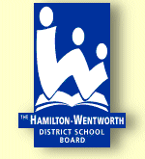

TEACHER: Mr. M.D’Alvise PREREQUISITE: N/A HOURS: 110 CREDIT VALUE: 1

DEPARTMENT HEAD: Mr. S. Ireland TEXTBOOK: Readings, As Provided

REQUIRED MATERIALS: Pen, Pencil, Markers, & requested materials as required.

GUIDELINE: The Ontario Curriculum, Grades 11 and 12: The Arts, 2010 (revised)

All reading resources will be provided without charge. The student is responsible for returning any requested resources in reasonable condition. The student will be charged for lost or damaged resources.

COURSE DESCRIPTION:
This course focuses on the exploration and creation of both traditional and contemporary crafts. Students will use the Creative Process to make artworks using a variety of materials and reflecting on a wide range of subjects. They will discuss and evaluate artworks utilizing the Critical Analysis Process. Students will explore and create works of art within a personal, contemporary, historical, and cultural context. Through the process of creation of artistic works, students will develop terminology, techniques, and learn responsible practices associated with visual art.
STRANDS and OVERALL EXPECTATIONS:
CREATING & PRESENTING
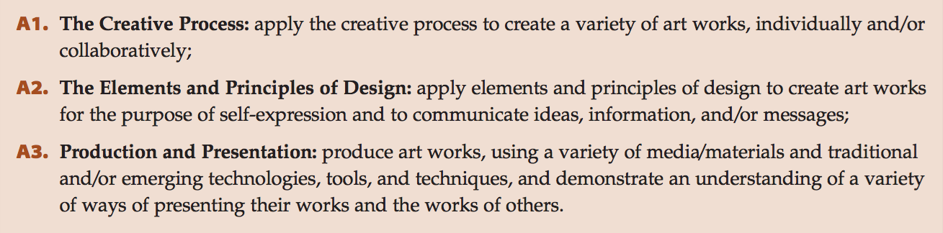

REFLECTING, ANALYSING, & RESPONDING
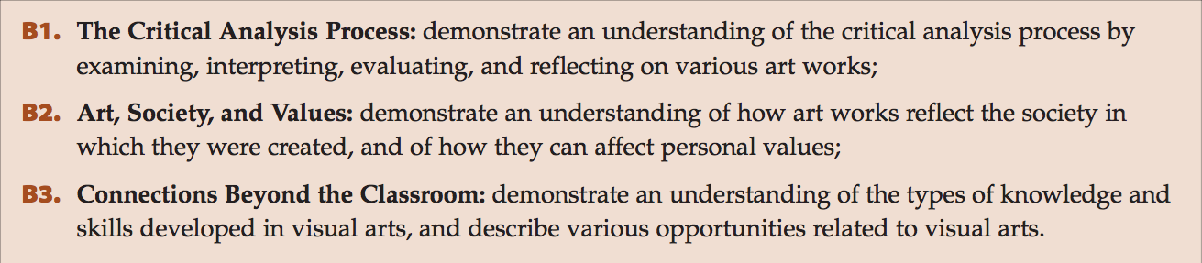
FOUNDATIONS
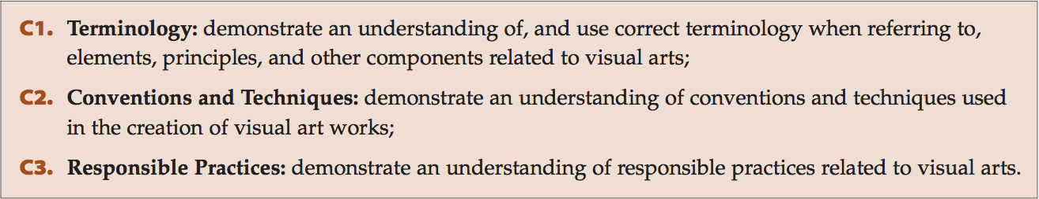

THE PRIMARY PURPOSE OF ASSESSMENT & EVALUATION IS TO IMPROVE STUDENT LEARNINGs

ASSESSMENT
The process of assessing student learning is continuous and ongoing. Teachers use information gathered through assessments to provide feedback for students, to guide instruction and develop individual learning goals for students. This is assessment for learning. Students use this feedback to continuously improve their achievement and set individual learning goals. This is assessment as learning. Information from assessments informs the teacher’s professional judgment, but is not used in determining the student’s level of achievement.

EVALUATION
Evaluation is the process of determining a level of student achievement of the Overall Expectations for a course, which is recorded as a mid-term or final grade on a report card.

Students will be given numerous and varied opportunities to demonstrate their achievement of the Overall Expectations across the four categories of achievement (Knowledge & Understanding, Thinking, Communication and Application). Evidence of student achievement of the Overall Expectations is collected over time from three different sources – observations, conversations and student products.

To be successful students must demonstrate achievement of EACH of the Overall Expectations for the course. If a student is missing evidence of achievement of one or more of the Overall Expectations then the teacher will determine a lower limit.

In determining a report card grade teachers use their professional judgment to interpret the evidence of student achievement, which reflects the student’s most consistent level of achievement with special considerations given to the more recent evidence.

The final grade is determined by the following breakdown:
70 % - evaluations made at the end of units throughout the semester.
30% - final demonstrations of learning (culminating activities and/or final examinations)

REPORT CARDS
Student progress is reported at 3 times during the semester.
Interim Report – October and March. Reports on student Learning Skills and Work Habits with next steps for improvement.
Mid-term Report Card – November and April. Reports on student achievement of the Overall Expectations to date. Incomplete achievement is reflected on Mid-term Report Cards, but replaced when learning has been demonstrated.
Final Report Card – February and July. Reports on student achievement of all of the Overall Expectations.

ACADEMIC HONESTY
Students are responsible for being academically honest in all aspects of their schoolwork. Academic dishonesty includes a variety of behaviours including cheating, plagiarism, facilitating or aiding academic dishonesty, and the unauthorized access or manipulating of student records, work and computer programs. Such behaviours impede the learning process and threaten the educational environment for all students.
Intentional academic dishonesty will result in disciplinary consequences. Teachers and parents should support students in striving for excellence and producing work with integrity.

ATTENDANCE AND LEARNING SKILLS
There is a direct link between good attendance and success at school. Students are expected to attend classes regularly and on time. Evidence of student achievement is gathered during classes through observations and learning conversations.

Learning Skills play an important role in a student’s level of achievement. Students will be assessed on the following learning skills: responsibility, works independently, collaboration, initiative, and self-regulation.

CELL PHONES/PERSONAL ELECTRONIC DEVICES
Teachers will determine when personal electronic devices, including cell phones, will be used as instructional tools/supports. At other times these devices (with the exception of electronic translators) are not to be used and must be turned off and be stored away. Consequences for inappropriate use of these devices may include removal of the device from the learning environment.

MARK CALCULATION BREAKDOWN:

Creating & Presenting 40%: The Creative Process & The Elements & Principles of Design
Reflecting, Analysing, Responding 10%: The Critical Analysis Process, Understanding Art & Society & Values, & Connections Beyond Classroom (Careers)
Foundations 20%: Concepts & Terminology, Contexts & Influences, Responsible Practices (Safety)
Culminating Activity 20%: Creating, Presenting, & Foundational Work
Culminating Reflection & Foundational Assessment 10%: Foundations, Reflecting, Analysing, & Responding to Artistic Works

SCHOOL WIDE SUPPORTS
- Student Support Team (formerly know as Learning Resource)  - In-class help  - Test and exam support  - Alternate learning environment  - English Language Learner Support Team  - Lunch-time help  - Test and exam support  - Math lunch-time help  - Math Homework Help – on-line support | - Information via school website @ http://schools.hwdsb.on.ca/glendale/  - School wide access to password protected wireless network  - Access to on-line resources  - Literacy Coaching  - Literacy @ Lunch  - Learning Commons @ Lunch  - Paper and electronic calendars  - Teacher/department Lunch-time/before/after school help

